The purpose of the program is to create three-dimensional images, computer graphics.

The program contains vectors, dots and geometric shapes realized by the programmer, it also has color, lighting and angles.

The program works in such a way that it shoots rays through the center of the camera to the center of each pixel and based on calculations paints it, the program also knows how to calculate reflection, level of clarity and opacity, architecture, type of material, blur or brightness.  
  
Things I learned in Proeject:

* Understanding how from theoretical study can be transferred to a written program.
* Understanding the world of graphics and design.
* Programming in a pair.
* Application of different techniques.
* Use in development bouquets Refactoring, Testting.
* Understand and work with a complex project.
* Acquiring skills in understanding the problem in depth and finding a suitable solution.

1. יצרנו רצפת שח-מט מפוליגונים, תמונה ישרה.

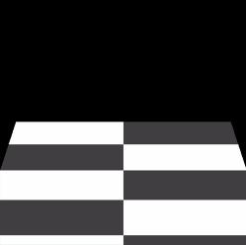

1. הוזזת זווית המצלמה.

1. הפעלת שיפורים.

1. כדור ללא תאורה אך שקיפות עדינה.

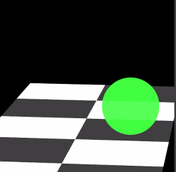

1. תמונה סופית כולל התאורה.

1.יצירת כדור ראשון

2.יצירת כדור שני

3.יצירת כדור שלישי

4.יצירת כדור רביעי

5.הוספת 2 סוגי תאורות, תמונה סופית.

